**Table of Content**

|  |  |  |  |
| --- | --- | --- | --- |
| **S. no** | **Particular** | | **Page no.** |
| 1 | Introduction | | 2 |
| 2 | Background | | 2 |
| 3 | Data Analysis Process | | 3 |
|  | 3.1 | Ask | 3 |
|  | 3.2 | Prepare | 3 |
|  | 3.3 | Process | 4 |
|  | 3.4 | Analyze and Share | 4 |
|  | 3.5 | Act | 11 |

**Introduction**

In this case study, I will perform many real-world tasks of a junior data analyst at a fictional Multi-Category retailer, Deepak Store. In order to answer the key business questions, I will follow the steps of the data process: Ask, Prepare, Process, Analyse, Share, and Act.

**Background**

**Deepak Store:**

* Deepak Store is a multi-category retail company. Deepak Store sells its product all around country.
* Deepak store wants to create an sales report for 2022. So that, Deepak Store can understand their customers and grow more sales upcoming festivals.

**Scenario:**

I am assuming to be a junior data analyst working in the marketing analyst team at Deepak Store, a Multi-Category retailer. The director of marketing believes the company’s future success depends on their customers and grow more sales in coming future. Therefore, my team wants to understand how different variables affected sales and growth of company in 2022.

From these insights, my team will design a new marketing strategy to grow more sales in upcoming year. But first, Deepak Store executives must approve our recommendations, so they must be backed up with compelling data insights and professional data visualizations.

**Data Analysis Process**

**Ask**

**Business Task**

Deepak store wants to create an annual sales report for 2022. So that, Deepak Store can understand their customers and grow more sales in 2023.

**Analysis Questions and Queries.**

1. Compare men customers with women customers for number of order and total sales.
2. Compare all age groups for numbers of order and total sales.
3. Compare All States for the numbers of orders and total sales.
4. Compare between married and unmarried for the numbers of order and total sales.
5. Classify number of orders and total sales according to occupations.
6. Find number of orders and total sales for each product category.

**Prepare**

**Data source**

I will use Deepak Store sales data to analyze and identify trends for 2022 which can be downloaded from GitHub website.

This is public data that can be used to explore how different customer types buying different products of Deepak Store from all over India.

**Data organization**

There is one CSV file named ‘Sales Data.csv’ includes information for Deewali sales data with column names such as 'User_ID', 'Cust_name', 'Product_ID', 'Gender', 'Age Group', 'Age', 'Marital_Status', 'State', 'Zone', 'Occupation', 'Product_Category', 'Orders', 'Amount'.

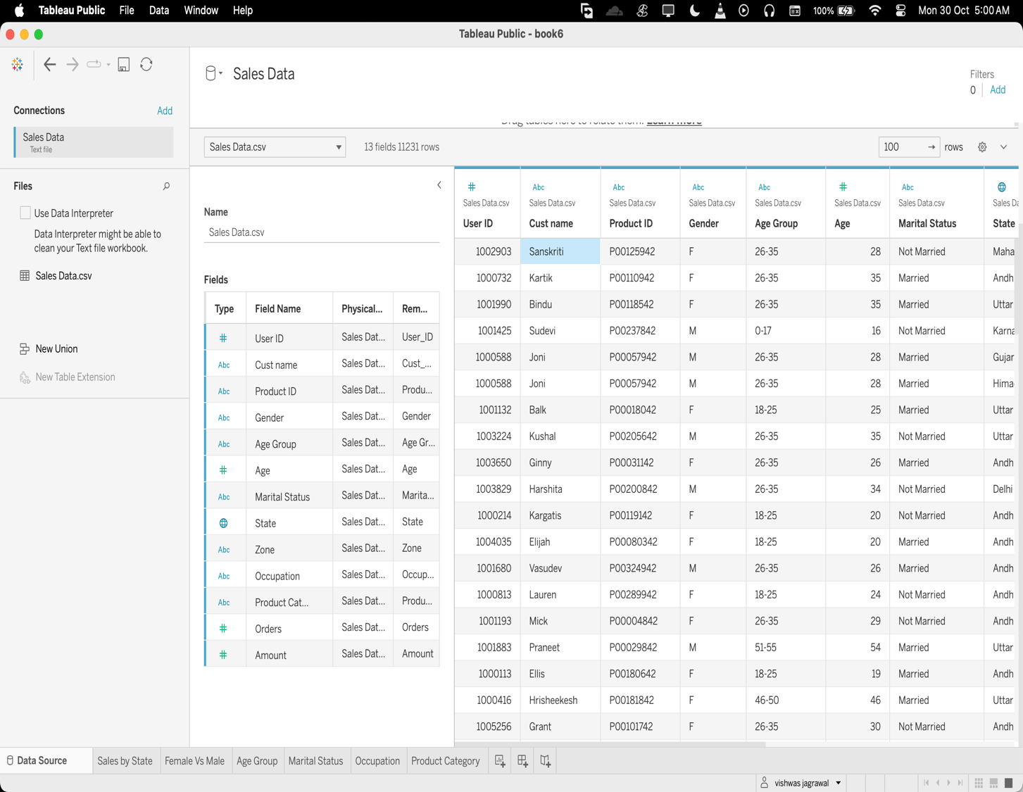

**Process**

**Data exploration**

Tableau Public is used for data exploration and to get familiarize with the data

**Analyse & Share**

After cleaning the data, it is ready for analysis. Tableau Public is used for Data analysis and visualization.

In data analysis we will find the answers to the Data Analysis Questions and Queries.

1. Compare men customers with women customers for number of order and total sales.

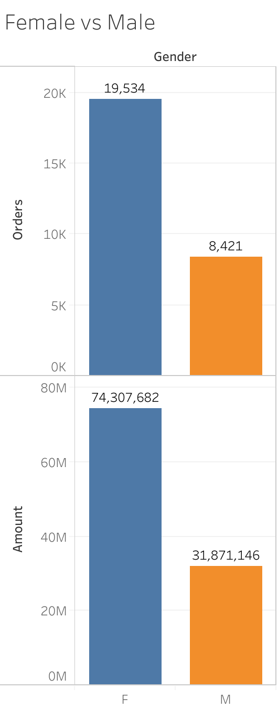

1. Compare all age groups for numbers of order and total sales.

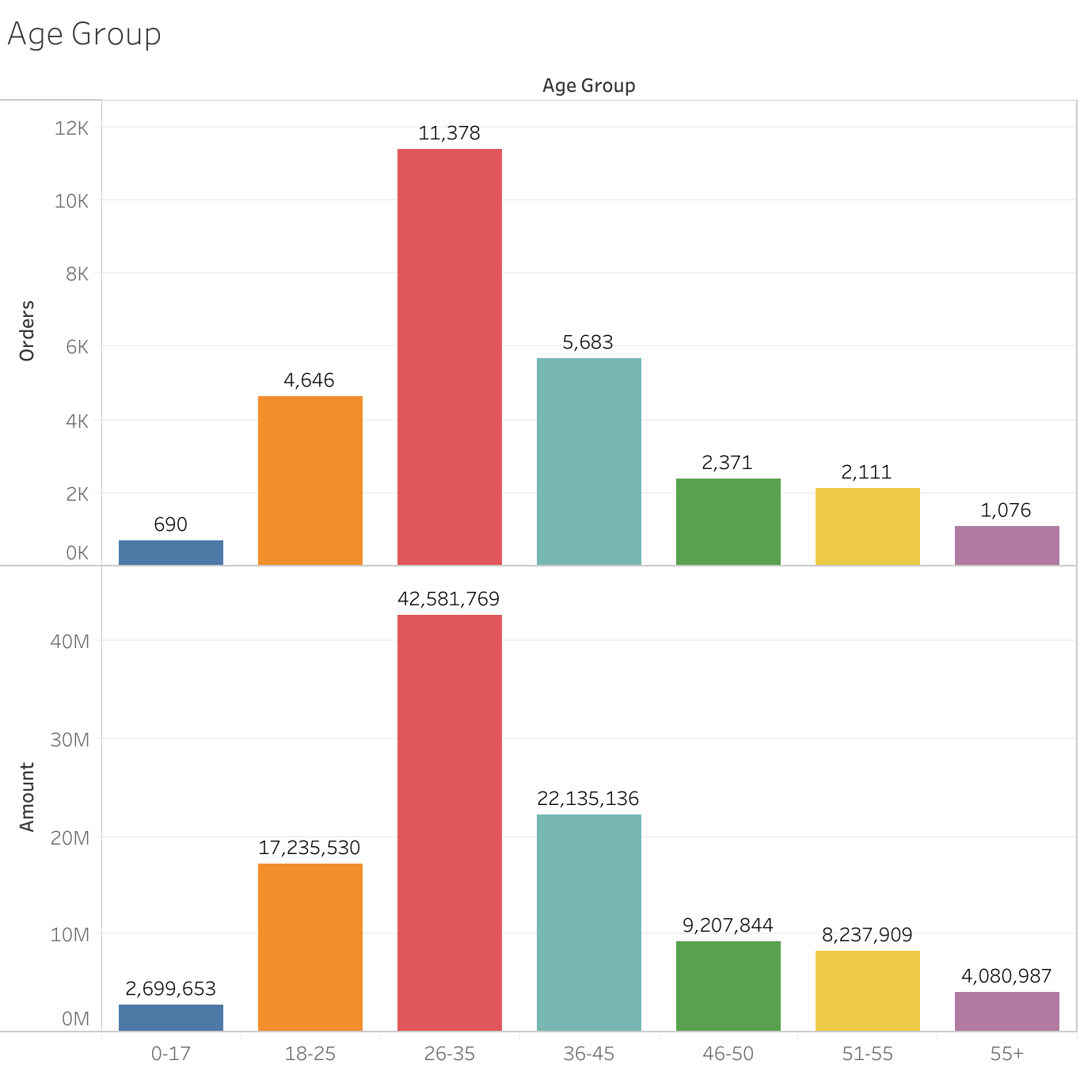

1. Find the number of order and total sales of top 10 states.

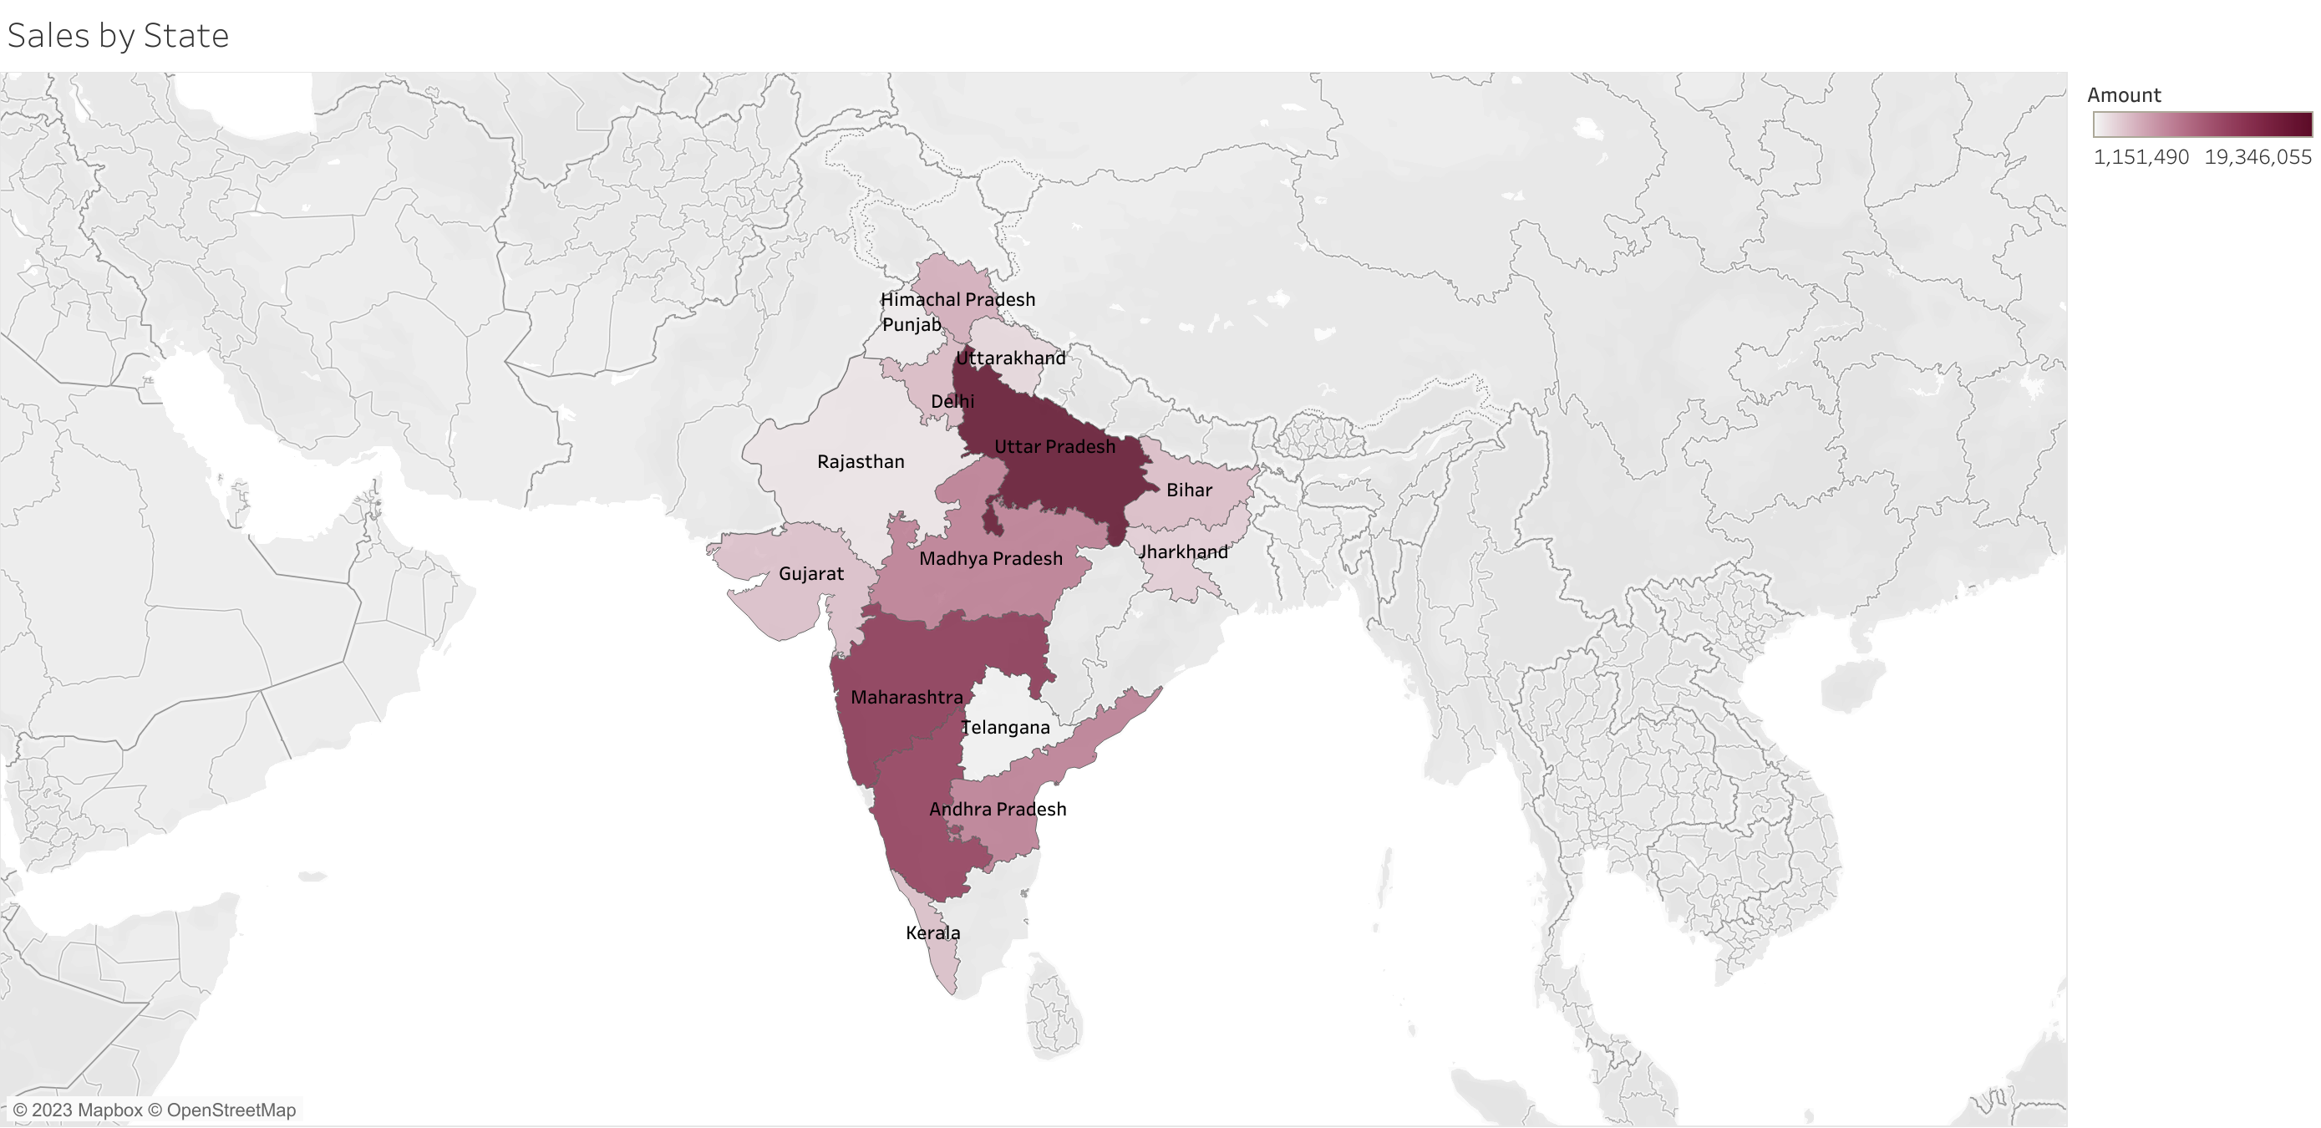

1. Compare between married and unmarried for the numbers of order and total sales.

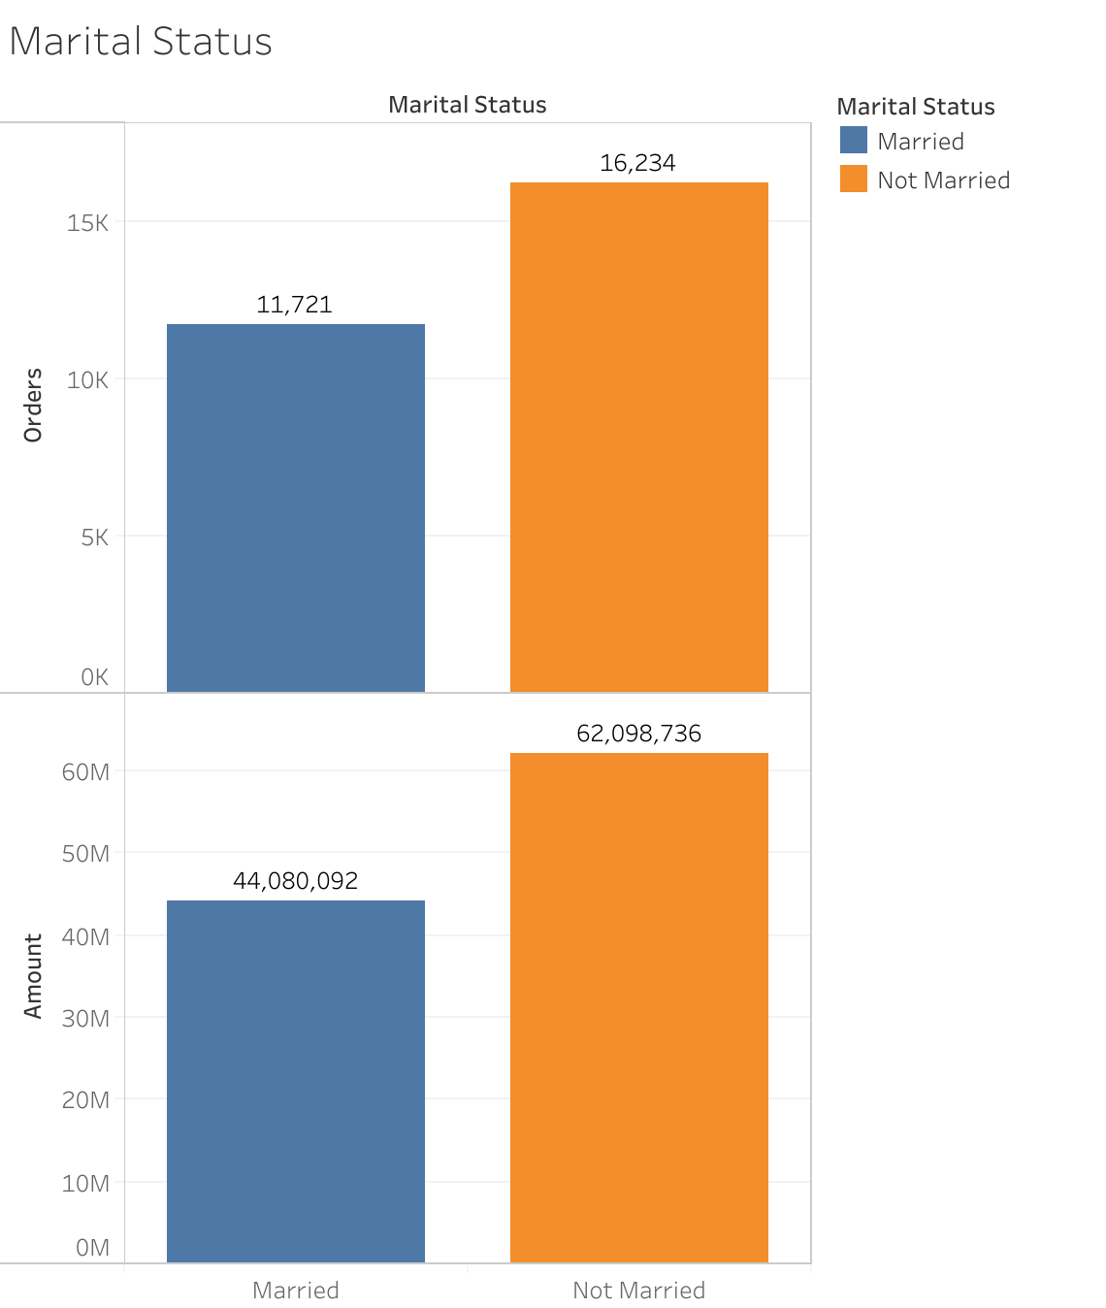

1. Classify number of orders and total sales according to occupations.

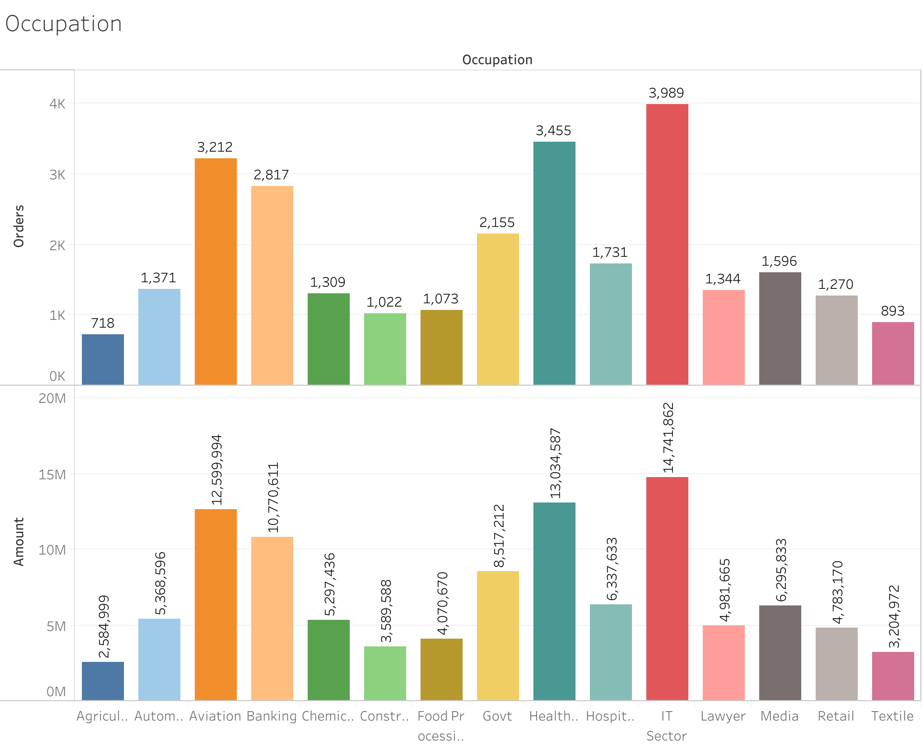

1. Find number of orders and total sales for each product category.

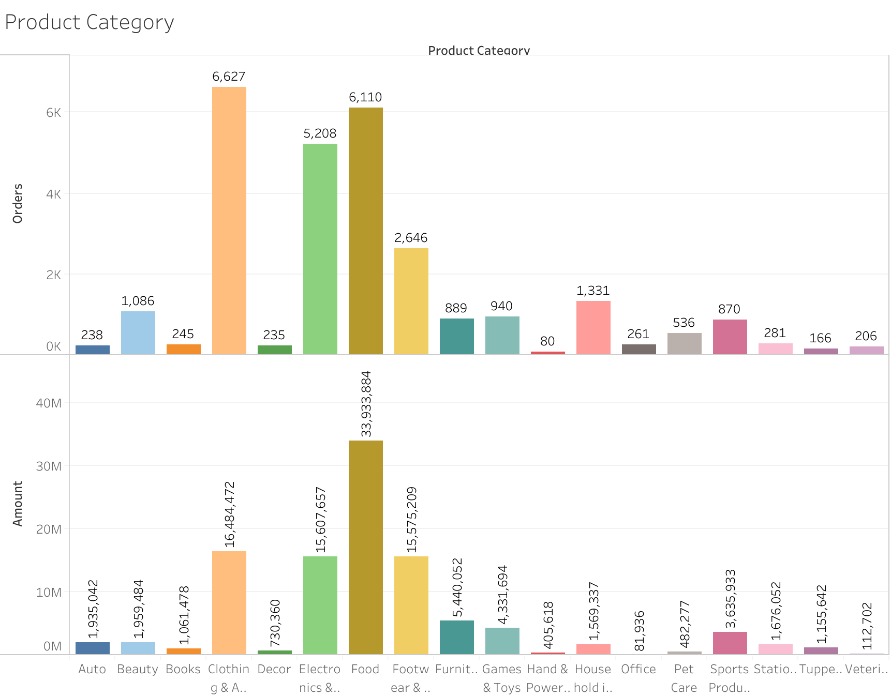**Summary of analysis**

* Most of the buyers are females and even the purchasing power of females are greater than men.
* Most of the buyers are of age group between 26-35 years female.
* Most of the buyers are married (women) and they have high purchasing power.
* Most of the buyers are working in IT, Healthcare and Aviation sector.
* Most of the sold products are from Food, Clothing and Electronics category.

**Act**

After thorough review of analysis of sales data of 2022 following points have been concluded.

* Women customers of the store have more purchasing power so store should focus more on the demand of women customer base but should also crate more demand among men customers.
* Store should introduce new product line focusing on women of age between 26-35 years.
* Store should exploit the demand of married women centric products as this category has the high potential of more purchase.
* Demand among the people working in IT, Healthcare and Aviation sector are very high, more analysis should be conducted in this area.
* More product lines can be ventured into within the category of Food, clothing and Electronics.